# Game Engines

## Task 2

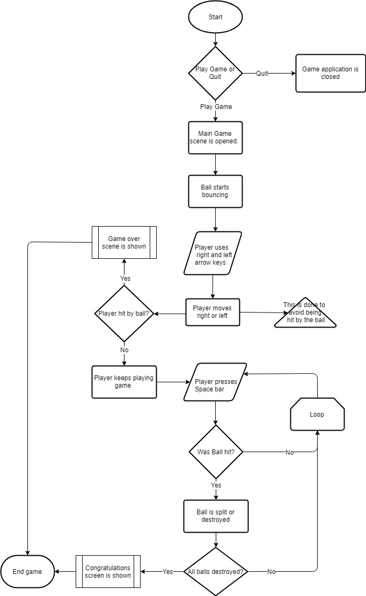

**Flowchart**

**Game Mechanics and Game Objectives**

The game mechanics of the game are relatively simple and straightforward. The player simply needs to press Left or Right arrow key (While always avoiding being hit by balls) and press Space bar to destroy the balls in order to win.

**Visual assets**



Background for game

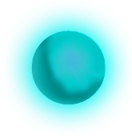

The objective/enemy (balls)

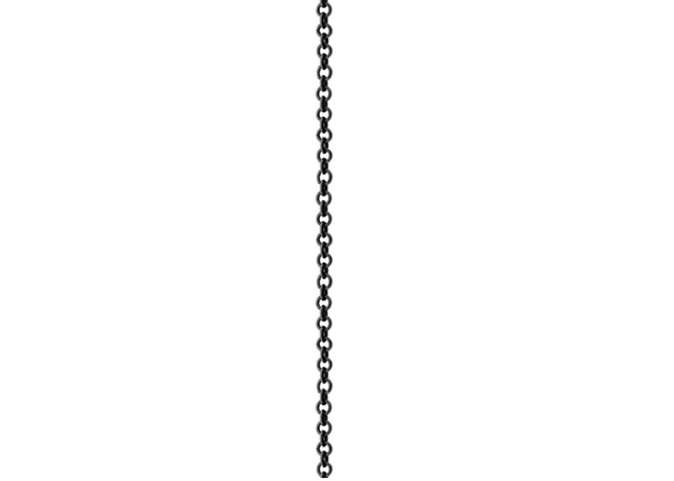 

The player

Chain/Spike/Ball Destroyer

**UI elements**

**Game Scenes**